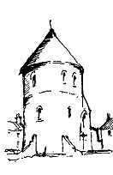
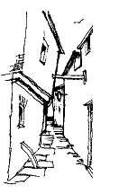
Newsletter
of the

Great Yarmouth Local History & Archaeological Society
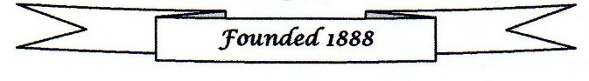


April 2026
Inside this Newsletter

Excursion booking form Page 1/2 Yarmouth Miniature Railway Page 4
GYLHAS AGM Page 3 An interesting note from the past Page 5

Recent activities of the GYYHAC Page 3 Review of ‘Fortune and the Forty Thieves’ Page 5

2026 Evening Visit – 19 June 2026

This year’s evening visit will be a guided walk along Great Yarmouth’s Marine Parade and is the Blue Badge Guided walk called, “Building Great Yarmouth’s Seafront”. This will be on 19 June 2026 and will start at 6pm at the front of the Wellington Pier. It is expected to last about 1.5 hours and will finish in the front of the Britannia Pier. It will be led by one of the town’s Blue Badge Guides. The theme of the walk will be the evolution of a seaside town and will be about some of the significant buildings along Marine Parade, such as piers, hotels and places of entertainment, that have contributed to the town’s holiday industry. If there are more than 20 people wishing to go on the walk, then we will be divided into two groups with the second group leaving slightly later than the first. Please note, therefore, to let us know of a contact phone number should we need to contact you of any changes to the planned walk.

Please note that the cost of the walk will be a charge of £5.00 per person to cover the costs of the walk.
How to Book:
- Send booking form with a cheque made payable to GYLHAS to: Michael Wadsworth, 38 Priory Street, Gorleston, Great Yarmouth, Norfolk NR31 6NG.
- Complete booking form and bring with a cheque made payable to GYLHAS to the next GYLHAS meeting.
- Make payment and email the booking form to mailto:infogylhas@gmail.com.
Preferred payment is via online banking using account name – GYLHAS Sort code 40 22 22 Account number 00401331 adding SEAF26 and your surname as a reference. If you are unable to pay by BACS, then payment can be made by a cheque made payable to GYLHAS and sent to Michael Wadsworth. Michael Wadsworth can be contacted on 07707 066629.

June Walk Booking Form

Name: Contact phone number:

Number of people attending: Amount paid: (BACS/Cheque)

Coach Excursion to Oxburgh Hall and the Bedingfeld Chapel/St. John the Evangelist Church, Oxborough on 15 July 2026

The 2026 coach excursion is to Oxburgh Hall, where we will have a guided tour which details the history of the hall, and then to the Bedingfeld Chapel, which is part of the Oxburgh Hall estate and St. John the Evangelist church which is the parish church of Oxborough. The excursion will be on Wednesday 15 July 2025. We will leave Oxburgh Hall at 4.00pm.

There will be four pick-up points:

1) The Tramway, Lowestoft Road Gorleston – 8.30am
2) The National Express coach stop, Market Gates (outside Costa Coffee) – 8.50am
3) Barnard Crescent – 9.00am
4) The Old Police Station, Caister – 9.15am

Please arrive at the pick-up point that you wish to board the coach at least 10 minutes prior to the time of the coach arrival.

The Coach will be free for members of the GYLHAS, but there will be a charge of £10.00 per person for non-members of the Society. The entrance to Oxburgh Hall and Gardens is free to National Trust members (please bring proof of membership with you on the trip. You will need to show your membership card before you enter) and for Non-members of the National Trust: £13.30 per person (Adult) and £6.65 Child under 18). The tour of the Hall is £4.00 per person. Please note that whilst there is no charge to visit the parish church at Oxborough, it is suggested that a voluntary donation of £1 per person be made to the church.

How to Book:
- Send booking form with a cheque made payable to GYLHAS to: Michael Wadsworth, 38 Priory Street, Gorleston, Great Yarmouth, Norfolk NR31 6NG.
- Complete booking form and bring with a cheque made payable to GYLHAS to the next GYLHAS meeting.
- Make payment and email the booking form to mailto:infogylhas@gmail.com.
Preferred payment is via online banking using account name – GYLHAS Sort code 40 22 22 Account number 00401331 adding TRIP26 and your surname as a reference. If you are unable to pay by BACS, then payment can be made by a cheque made payable to GYLHAS and sent to Michael Wadsworth. Michael Wadsworth can be contacted on 07707 066629.
Summer Excursion Booking Form
Name(s): Contact phone number:

Address:

- Number of coach places required: GYLHAS member FREE: (Non GYLHAS member £10.00 per person)

- Number of Oxburgh Hall tickets required: £13.30 per person for non-National Trust members - Oxburgh Hall (National Trust members £0.00)

- Number of Oxburgh Hall guided tours required: £4 per person

- Pick up point: Tick where applicable
- The Tramway, Lowestoft Road, Gorleston – 8.30am
- National Express Coach stop, Market Gates (outside Costa Coffee) – 8.50am
- Barnard Crescent – 9.00am
- The Old Police Station, Caister– 9.15am

I enclose a cheque/PO made payable to GYLHAS for: £

I have made a BACS payment to GYLHAS for £
Name(s):

GYLHAS 2026 AGM

Please note that the 2026 AGM of the Great Yarmouth Local History and Archaeological Society will be held on 15 May 2026. The meeting will be held at the Salvation Army Citadel, Tolhouse Street, Great Yarmouth and will start at 7.30pm. The AGM agenda and reports will be circulated separately from the Newsletter.

There will be on the same evening a lecture entitled Uncovering Great Yarmouth – Results of the 2022-23 Excavation and Surveys given by Joanna Caruth (Cotswold Archaeology). Please make every effort to attend this important meeting.

Recent activities of the Great Yarmouth Young History and Archaeology Club

At the recent meeting, members of the Great Yarmouth Young History and Archaeology Club visited the Wreck and Rescue Gallery at the Time and Tide Museum, to explore the dangers once faced along the Norfolk coast. Ann Dunning brought a gansey she is knitting and explained how each family had its own pattern, sometimes the only way to identify a lost sailor.

The group learned about the early beach companies who raced to reach wrecks and how these crews evolved into today’s RNLI and the independent Caister Lifeboat. We also looked at the museum’s displays to find out how lifesaving equipment has developed over the centuries.
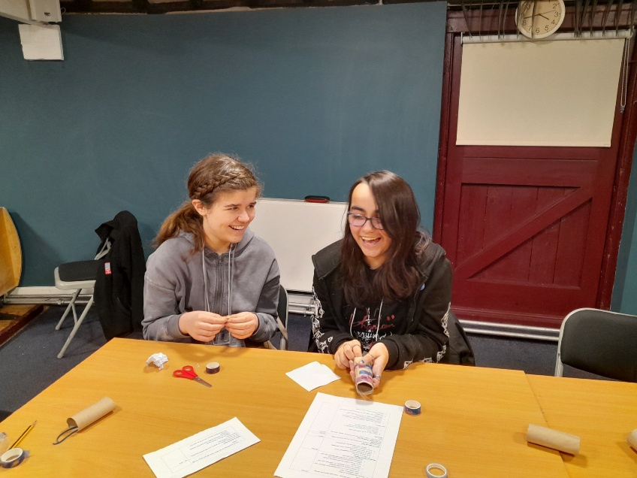
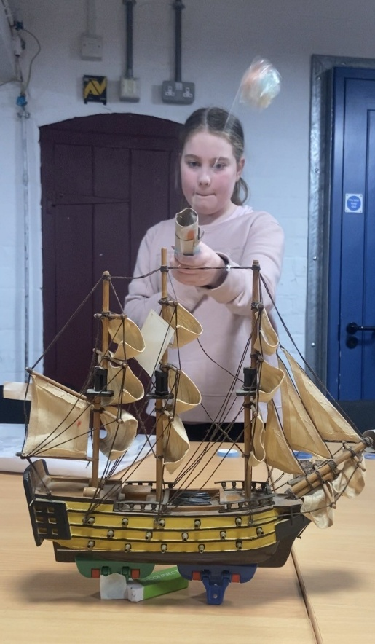
The young people were introduced to the story of Captain George Manby, whose mortar for firing a line to stranded ships revolutionised rescue work. Using a rescue line and a ‘Barbie Ken’ doll, we tried out an improvised version of the breeches buoy in the fishing gallery.

To round off the session, members designed and built their own Manby mortars from cardboard tubes and elastic bands, attempting to land a breeches buoy on a model “ship”. Some launches were more accurate than others, but the activity was a hit with everyone.

P. Day

Yarmouth Miniature Railway

Members may be interested in an article recently published by the author, Peter Scott, about Yarmouth Miniature Railway, as follows:

Mr. Scott quotes: “My research on the Yarmouth Miniature Railway is downloadable for free (but please see note about suggested donation) from my web site at:

http://www.minorrailways.co.uk/publications.php. Scroll down to Mini Histories No.9.

The Mini Histories series are available as free downloads. Please respect copyright when using these downloads. You are welcome to download the books for personal use and research, but please consider making a suitable donation to the Alzheimer’s Society. Permission must be requested before reproducing any of the content in any form. Thank you.”

J. Smail

An interesting note from the past

An interesting note from the past in the newspaper the Eastern Daily Press of 20th May 1879.
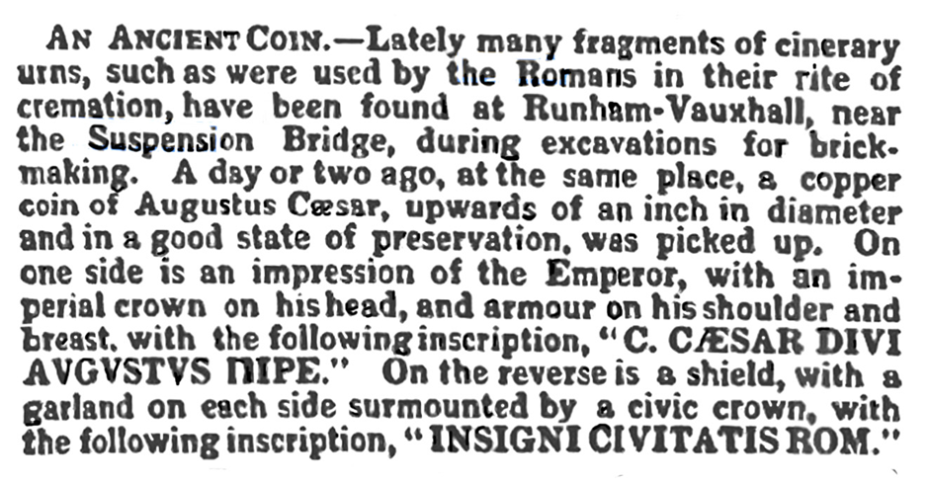
The inscription "caesar divi augustus nupe" on the coin means "Caesar, son of the divine, Augustus, father of the nation." This inscription is a declaration of Augustus' divine lineage and his claim to the title of Caesar, which was given to him by the Senate in 27 BC. The term "divi" refers to the divine, and "augustus" means "noble" or "majestic." This inscription is a significant part of Augustus' identity and his efforts to legitimize his rule as the emperor of Rome.

Caesar Augustus (63 BCE-14 CE) was the Roman Emperor from 27 BCE-14 CE. He was allegedly fed poisoned figs by his third wife, Livia.

P. Davies

‘Fortune and the Forty Thieves’ by David Higgins

Published in 2025 by Phoenix Publications, Fortune and the Forty Thieves is the first novel by David Higgins. Fortune and the Forty Thieves is a historical novel, a genre which includes Bernard Cornwell’s Sharpe and C. S. Forester’s series of Hornblower novels. It concerns the adventures of Luke Fortune, a Yarmouth Beachman. The historical background comes from the historical research carried out for Higgins’ earlier non-fiction books about Norfolk, in particular for his book about the lives of the local Beachmen during the Nineteenth Century. In the mix that goes to form the background of this novel is smuggling, the threat of being press-ganged, and the dangers of earning a living from the sea set against the background of war. Set in 1794 during the French Revolutionary Wars (1793 to 1802), Norfolk was in the frontline against the French and their allies which saw Yarmouth becoming an important supply base for the Royal Navy and the stationing of militia from outside the county to counter the threat of invasion. Places mentioned in the story are real locations and are described as they were during this period. The characters, apart from a few actual historical figures, are fictitious and there is the use of genuine nicknames and local dialect. At the end is a useful glossary of nautical and dialect terms.

M. Wadsworth

