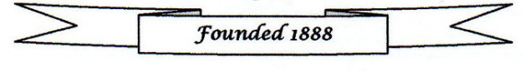


2026 Evening Visit – 19 June 2026

This year’s evening visit will be a guided walk along Great Yarmouth’s Marine Parade and is the Blue Badge Guided walk called, “Building Great Yarmouth’s Seafront

Please note that the cost of the walk will be a charge of £5.00 per person to cover the costs of the walk.
How to Book:
- Complete the booking form and send with a cheque made payable to GYLHAS to: Michael Wadsworth, 38 Priory Street, Gorleston, Great Yarmouth, Norfolk NR31 6NG.
- Complete the booking form and bring with a cheque made payable to GYLHAS to the next GYLHAS meeting.
- Complete the booking form and email to infogylhas@gmail.com. Payment can also be made via online banking using account name – GYLHAS Sort code 40 22 22 Account number 00401331 adding SEAF26 and your surname as a reference.

June Walk Booking Form

Name: Contact phone number:

Number of people attending: Amount paid: (BACS/Cheque)

