**Newsletter**

of the

Great Yarmouth Local History & Archaeological Society

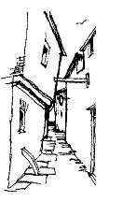

**July Coach Trip 2025**

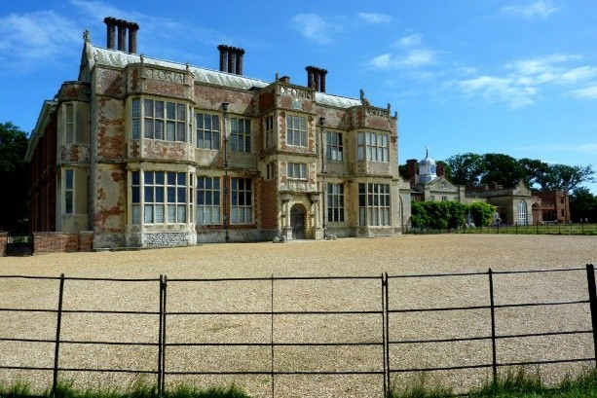This year’s Coach Trip is on Wednesday 23 July 2025. There are still plenty of seats available on the coach. We will be visiting the remains of the Roman town Venta Icenorum (*“The marketplace of the Iceni”*) at Caistor St Edmund in the morning. Here we will be given a guided tour around the site by a member of the Norfolk Archaeological Trust, who are responsible for the site. Toilet facilities at the site will be open to those needing them. We will then be going to Felbrigg Hall, which is owned by the National Trust. Whilst at Felbrigg Hall, you will be able to look around the Hall, the grounds and the Walled Garden. We will leave Felbrigg Hall at 5pm. It is hoped to be back in Gorleston by 6.40pm.

There will be four pick-up points:

1) The Tramway, Lowestoft Road, Gorleston – 8.30am, 2) Stand A, Market Gates (outside Poundstretcher unless moved elsewhere) – 8.50am, 3) Barnard Crescent – 9.05am, 4) Caister Police Station – 9.15am.

The cost of the trip will be – Coach seat £15.00 per person, the tour of Venta Icenorum at Caister St Edmund is £5.50 per person, and Felbrigg Hall and Gardens is£15.00 per person for non-members of the National Trust and free for National Trust members (please note that if you are a member of the National Trust, you will need to show your National Trust membership card to gain free entry). For non-members of the Society there is an extra £2.00 per person to cover insurance. To book a place on this trip, please complete the booking form on Page 2 and return it to Michael Wadsworth, 38 Priory Street, Gorleston, Great Yarmouth, Norfolk NR31 6NG.

Payment can be made either by cheque (made payable to GYLHAS), or cash. Payment can also be made via online banking using account name – GYLHAS Sort code 40 22 22 Account number 00401331 adding TRIP 25 and your surname as a reference. Please provide a contact phone number for yourself just in case there are any last-minute changes.

**Michael Wadsworth**

**Inside this Issue**

Coach Excursion Booking Form Page 2

NAHRG Norfolk Landscape History Day Page 3

2025 Day School on 10 May 2025 Page 4

Memories of World War II Page 4

Second World War HAA Battery at Mautby Page 4

**Coach Excursion to the Roman remains of**

**Venta Icenorum at Caistor St Edmund and**

**Felbrigg Hall on Monday 23 July 2025**

# Booking Form

If you wish to join the coach trip, please complete this form and send with a cheque made payable to GYLHAS and send it to: Michael Wadsworth, 38 Priory Street, Gorleston, Great Yarmouth, Norfolk NR31 6NG. Payment can also be made via online banking using account name – GYLHAS, Sort code 40 22 22, Account number 00401331, adding TRIP 25 and your surname as a reference.

Name(s):

Contact phone number:

Address:

Number of coach places required (£15.00 per person):

Venta Icenorum tour (£5.50 per person):

Felbrigg Hall (£15.00 per person for non-National Trust members):

Felbrigg Hall (National Trust members £0.00) - Please bring your National Trust membership card:

Pick up point:

Tramway, Lowestoft Road, Gorleston – 8.30am

Stand A Market Gates (outside Poundstretcher) – 8.50am

Barnard Crescent – 9.05am Caister Police Station – 9.15am

Insurance for Non-members £2.00:

I enclose a cheque/PO for: £



**2025 Day School - East Anglia in the Anglo-Saxon Period: Illuminating the ‘Dark Ages’**

On 10 May 2025, the Great Yarmouth Local History & Archaeological Society held a very successful Day School entitled *East Anglia in the Anglo-Saxon Period: Illuminating the ‘Dark Ages’*.

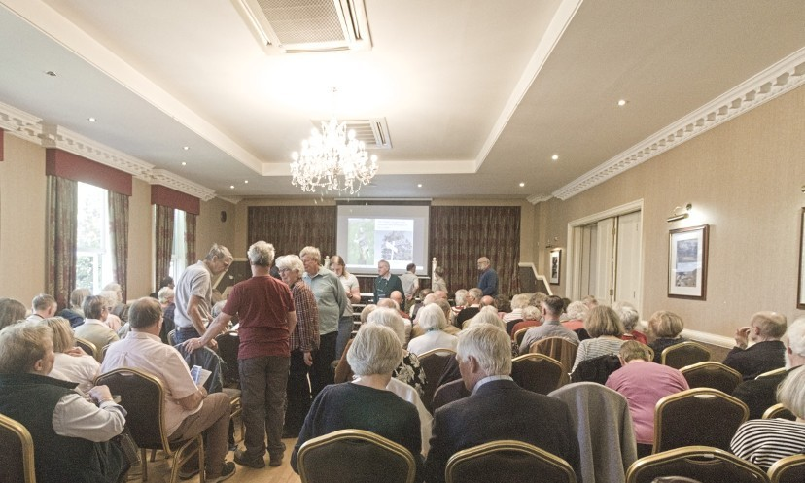

Held at the Imperial Hotel, it was attended by over 90 people. The speakers were Professor Katy Cubitt, Professor Lesley Abrams, Dr. Keith Ruiter and Professor Rory Naismith. The proceedings were opened by the High Steward for Great Yarmouth, Henry Cator. A full report of the proceedings will be in the next Journal.

**Memories of World War II**

With the recent anniversaries of ‘Operation Varsity’ (the Crossing of the Rhine) and V.E. Day I recall an incident the late and very much missed former Chairman and President of Great Yarmouth Archaeological Society, Norman Fryer (1924-2016), recalled to me about one his wartime experiences. Flight Sergeant Fryer was flying as the rear gunner in a Stirling bomber towing a glider with men or materials to land in the Third Reich in March 1945.

He saw a glider fall to pieces in mid air and a Jeep tumble from back of the aircraft. Then he saw two men with outstretched arms and legs fall from the wreckage almost certainly to their deaths. Norman dwelt on what was going through these men’s minds as they fell to the end of his life.

It was later concluded that the Jeep was left in gear and was started in the aeroplane causing it to crash out of the plane as it broke up in mid air. When he mentioned the incident to a medical man he was told that the men would have probably been unconscious as they fell to Earth.

The tragedy and random nature of war remained with him for the rest of his life and that two young men who had survived almost to the end of the conflict were lost to their families.

**Andrew Fakes**

**Second World War HAA Battery at Mautby**

The Heavy Anti-Aircraft Battery (HAA) near Mautby was added to the Historic England’s ‘At Risk’ Register in 2023. It has been described by Historic England as ‘probably the most complete HAA battery of its type in England’. Tree planting and plant growth has led to the loss of some masonry and one of the underground shelters has collapsed. In conjunction with Historic England, Great Yarmouth Borough Council is seeking to reduce the damage caused by the trees and is looking at possible ways to preserve what remains. Known as YH4 in the military records, the remains of this World War Two heavy anti-aircraft gun battery is situated near to Decoy Farm in a wooded area north of the low-lying marshland of the River Bure. The site consists of four-gun emplacements, a command past and part of the access road. It is a Scheduled Monument and was first listed as such on 23 July 2018. As stated in the Historic England website, the site was designated as a scheduled monument because it is a wellpreserved Heavy Anti-Aircraft battery which retains its core structures including a command post and four gun emplacements, both retaining evidence of their original fittings as well as being a rarity in that not only has it been identified as one of a small number of complete or near complete Second World War gun batteries, but it is probably the most complete HAA battery in England constructed with four gun emplacements to the Directorate of Fortifications and Works (DWF) specification drawing DFW55483/1.

In addition to this, it is pointed out in the Historic England website that it is one of the few obvious and tangible facets of Britain’s wartime air defence system, one which stands testament to a specific form of twentieth century warfare and to national defence policy and that the gun emplacements and command post will enhance our detailed understanding of the construction, function and use of this military site type in Britain, along with Anti-Aircraft Command's advances in gunnery and military tactics during the course of the conflict and although the domestic site and sewage treatment plant have been lost, it is still a legible ensemble, in which the functioning of the gun emplacements and command post is strongly sensed and the military experience readily captured. Also, it provides an exceptional insight into the development of anti-aircraft measures during the Second World War, with it being a significant, visible reminder of the nature of home defence during the conflict.

To deal with the bombing raids carried out in World War 2 by the Luftwaffe, heavy anti-aircraft (HAA) gun sites were built at major installations and ports around the UK and almost 1000 were constructed nationally. The standard weapons deployed at these sites were 3.7 inch and 4.5-inch calibre heavy antiaircraft guns, operated by almost 275,000 men, supplemented by women soldiers from the Auxiliary Territorial Service (ATS) from 1941 onwards. The gun emplacements were usually arranged in groups of 2, 4 or 8 and most sites had a command post, a radar platform, a gun store and a magazine for storing reserve ammunition. A variety of typical military hutting made up the domestic section of the site, usually a combination of Nissen and timber huts placed on concrete building platforms. Most domestic sites also had workshops and garages, and very often a sewage treatment plant. HAA sites were also provided with structures for their close defence, with light anti-aircraft (LAA) gun pits, searchlight emplacements and pillboxes being common. Due to their inflexibility, most of the Second World War HAA sites were abandoned during the war, but a small number were retained as part of the Nucleus Force and adapted for Cold War use.

As in other parts of the country (apart from London), Norfolk's HAA batteries were organised into Gun Defended Areas (GDAs), each protecting one or more targets or Vulnerable Areas (VAs). The battery at Mautby (known from military records as site YH4) was one of five HAA batteries deployed to defend Great Yarmouth as part of the Yarmouth and Lowestoft GDA. It is not clear exactly when the battery was built, but its layout suggests that the operational element of the site was built after the Directorate of Fortifications and Works issued specification drawing DFW 55483/1 in September 1943. There is evidence that the batteries defending Great Yarmouth were in place by June 1942, although it does seem that the battery at Mautby had been built by this date. It appears from the existing records that YH4 was originally located at the town's racecourse, probably as a mobile HAA unit, before being moved to Decoy Farm, Mautby, at some point after September 1943.

The battery was still in existence and was still in full use in July 1946. Under the Nucleus Force scheme three of Great Yarmouth’s batteries were retained to form part of the post-war HAA layout. The batteries at West Caister (YH1) and Gorleston (YH2) were Battle Headquarters (BHQs), with their weapons remaining in situ, while Mautby (YH4) was designated an ‘Off site’, with its weapons and firecontrol instruments stored in nearby depots. However, with the development of nuclear weapons and surface-to-air missiles rendering conventional anti-aircraft artillery of this type obsolete, the site was abandoned shortly afterwards. Some of the buildings had been demolished by March 1955. Tree planting around the site began sometime in the 1970s. At some point, some of the remains were used by a local gun club as an indoor shooting range.