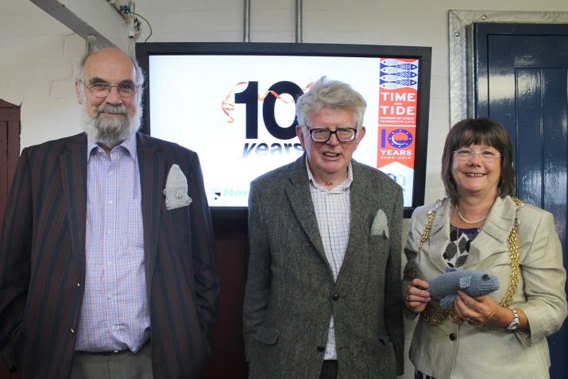
The President and the Chairman
of the Society were invited to join the celebrations for the Time and Tide Museum’s 10 year birthday. As well as a talk on the great achievements of the Museum over the last 10 years, a buffet lunch was provided and a birthday cake was cut.

The £4.8 million pound project, which opened in 2004, in a converted and derelict fish curing works was a great leap of faith. Over the years the museum, with its dedicated staff, has gone from strength to strength and has obtained international and national acclaim. Over the years it has attracted a third of a million visitors. In 2013 the figure of 8,500 school visits was logged. May its success continue for many years to come.

P Davies

Click here to read local press coverage

