Great Yarmouth Local History & Archaeological Society
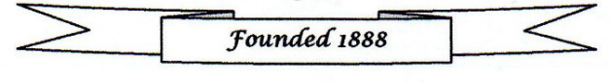
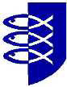

Coach Excursion to Oxburgh Hall and the Bedingfeld Chapel/St. John the Evangelist Church, Oxborough on 15 July 2026
How to Book:
- Send booking form with a cheque made payable to GYLHAS to: Michael Wadsworth, 38 Priory Street, Gorleston, Great Yarmouth, Norfolk NR31 6NG.
- Complete booking form and bring with a cheque made payable to GYLHAS to the next GYLHAS meeting.
- Email booking form to mailto:infogylhas@gmail.com. Payment can also be made via online banking using account name – GYLHAS Sort code 40 22 22 Account number 00401331 adding TRIP 26 and your surname as a reference.

Name(s): Contact phone number:
Address:

- Number of coach places required: GYLHAS member FREE: (Non GYLHAS member £10.00 per person)

- Number of Oxburgh Hall tickets required: £13.30 per person for non-National Trust members - Oxburgh Hall (National Trust members £0.00)

- Number of Oxburgh Hall guided tours required: £4 per person

- Pick up point: Tick where applicable
- The Tramway, Lowestoft Road, Gorleston – 8.30am
- National Express Coach stop, Market Gates (outside Costa Coffee) – 8.50am
- Barnard Crescent – 9.00am
- The Old Police Station, Caister– 9.15am

I enclose a cheque/PO made payable to GYLHAS for: £

I have made a BACS payment to GYLHAS for £

