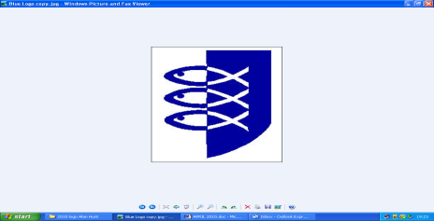
Great Yarmouth Local History
& Archaeological Society
Privacy Policy
- Statement of Intent
The purpose of this privacy statement is to provide you with details of how Great Yarmouth Local History and Archaeological Society (GYLHAS) will collect, store and use the personal data you supply to it.
Personal data is information which relates to identifiable living individuals. GYLHAS will always collect and process personal data.
in accordance with current legislation.

- Collection of Personal Data
As a member of GYLHAS you will be asked to provide certain personal data as is required to enable registration of membership. This information will not be used for any other purposes. By providing such information you consent to its use and storage in accordance with the provisions of this Privacy Policy.

- Use of Personal Data
GYLHAS will only use your data for the purposes for which it is provided (membership) or for additional purposes to which you have consented (newsletter and GYLHAS events and information from similar organisations which the committee agrees contains cultural or heritage information of interest to members) We do not allow third parties to use the data we collect.

- Storage, Correction and Deletion
GYLHAS will retain the personal data it holds for the term of your membership or until you send us notice that you no longer wish us to retain this data. We will supply you with a copy of the personal data we hold about you if you contact GYLHAS by post or by email (see website for contact details). Should you discover any inaccuracies in please notify us as soon as possible and we will then correct our records.

We may make changes to this Privacy Policy by posting the new version on this website

